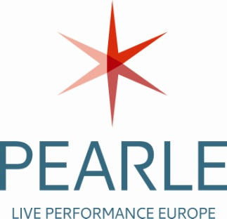

Press release
Two online tools to assess risks in venues and for productions in the live performance sector
Brussels, 17 September 2015
Today, the European social partners of the live performance sector launched two online interactive tools to support risk assessment.
The Live Performance sector encompasses workplaces with such a diversity of elements to be considered in relation to occupational health and safety, that they can prove an enormous challenge. When one considers the technical elements in relation to set, rigging and stage; the stunts and performances on the stage; the chemical and hazardous substances that may be used in special effects; frequent high noise levels and the presence of an audience; it is clear that special, sector-specific risk assessment approaches are vitally necessary to prevent accident and injury.
For that reason the European social partners of the live performance, Pearle* and EAEA, decided in 2012 to start developing an Online interactive Risk Assessment (OiRA) tool. Three years of intensive work have in fact resulted in two tools: one of which is geared towards venues in the performing arts and one which is intended to facilitate risk assessment for productions. Certain modules and elements are common to both and both include a specific section addressing the vital coordination and communication between between venue and production.
OiRA can be used by anyone wishing to assess health and safety-related risks that might exist in their workplace. The OiRA tools for the Live Performance sector have been developed to give venues, production companies and all those working in the sector a roadmap to address the various challenges in the sector.

Anita Debaere, Director of Pearle*, representing some 7000 employers through its members, welcomes the launch, saying: "The tools help every company (in particular those with the size of an SME, small and medium sized company) to consider implementing a health and safety policy in the organisation and to take measures which minimise and avoid risks. By doing so, those working in the sector learn to adopt approaches that go beyond the common sense practice but rather adopt an attitude which consider in the various aspects of the work a safety management approach."

Dearbhal Murphy, coordinator for the workers represented by FIM, FIA and Uni-Mei in the European arts and entertainment alliance EAEA, adds: "The OiRA tool is an excellent introduction for those in the sector who are unfamiliar with the process of risk assessment. The real aim is to help to develop a culture of risk assessment in the sector by simplifying the process and making it part of everyday working for all active in the sector, regardless of size”.

The European Agency for Health and Safety at Work operates the technical maintenance of the tools and promotes the use of the tool through its partners in the EU Member States. The tool is developed in the framework of a European social partner project with the financial support of the European Commission.

The OiRA tools are available on http://www.oiraproject.eu/oira-tools and from the project partner websites. Later this year, the tool will be translated into Spanish.

Contacts:
Dearbhal Murphy  Deputy General Secretary FIA  European Arts and Entertainment Alliance (EAEA)  Tel: +32-2-234.56.53  e-mail: dmurphy@fia-actors.com  www.fia-actors.com | Anita Debaere  Director  PEARLE* - Live Performance Europe  Tel : +32-2-203.62.96  e-mail: anita@pearle.ws  www.pearle.ws

